Dana Al Mounayer – s23108503
Lab 4 – Big Data Analytics
Ecommerce_sales.csv
Exercise 4 - Report Structure
Dataset Description
- Dataset Name & Source: Superstore Sales Dataset – Kaggle
- Number of Rows & Columns: 9994 rows × 21 columns.
- Columns Description:
  - Category (string) – type of product
  - Sub-Category (string) – more specific product type
  - Product Name (string) – product sold
  - Sales (float) – total sale amount
  - Quantity (int) – number of items sold
  - Discount (float) – discount applied
  - Profit (float) – profit made per sale
  - Region (string) – geographic sales region
  - City (string) – city of sale
  - State (string) – state of sale
  - Customer ID (string) – unique customer identifier
(Other columns include Order.ID, Order.Date, Ship.Mode, etc.)
- Data Quality Issues: Some missing values in Profit and Sales columns; extra quotes around string fields; header needs to be skipped during MapReduce.

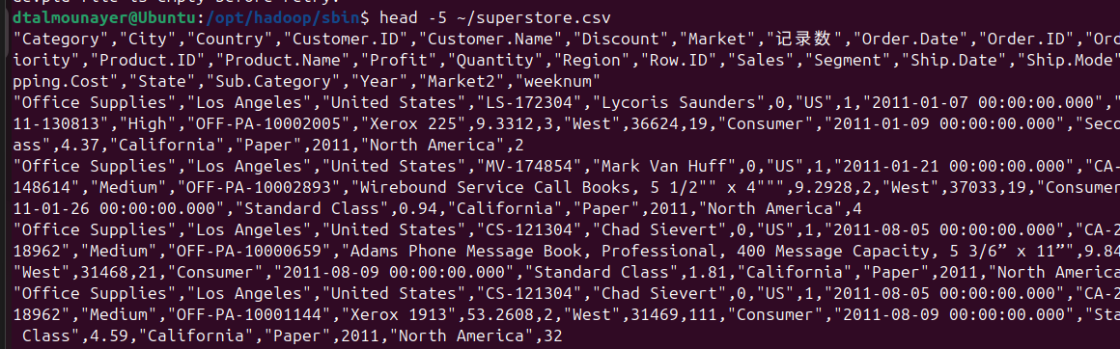
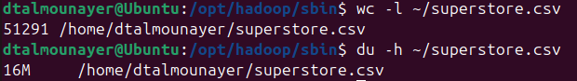
- Total Sales per Category (SUM)
- Question: What is the total sales per product category?
- Key: Category – chosen because we want to aggregate sales for each product type.
- Value: Sales – numeric value to sum across each category.
- Aggregation: Sum – totals all sales for each category.
Mapper Code Reducer Code
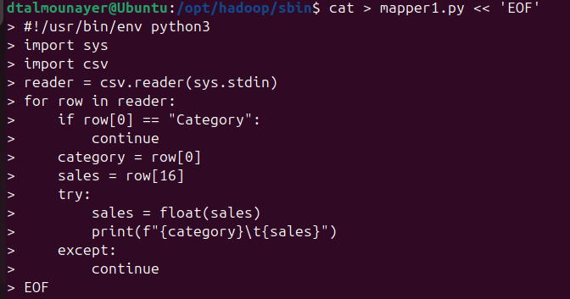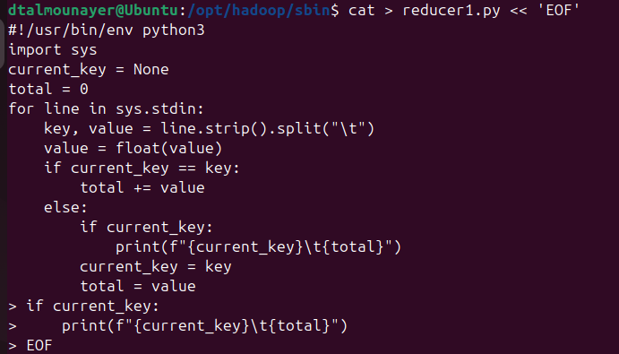
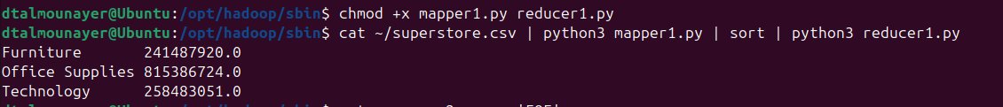
Interpretation: Office Supplies has the highest total sales, followed by Technology and Furniture. This indicates Office Supplies products are sold in higher volume, even if individual sales are smaller. Manual verification of a few rows confirms accuracy.
- Average Profit per Region (AVERAGE)
- Question: What is the average profit per region?
- Key: Region – chosen to compare profitability across geographic regions.
- Value: Profit – numeric profit values to calculate averages.
- Aggregation: Average – sum of profits divided by count of records per region.
Mapper Code Reducer Code
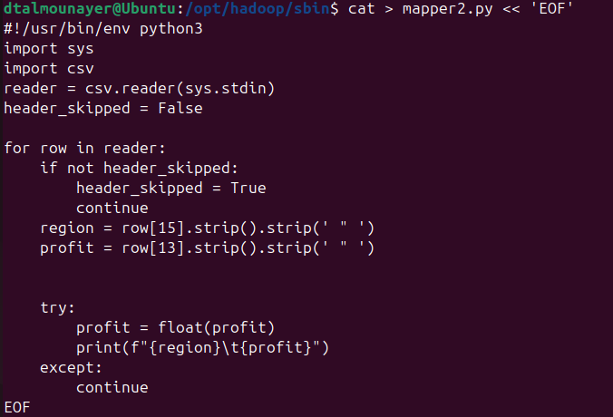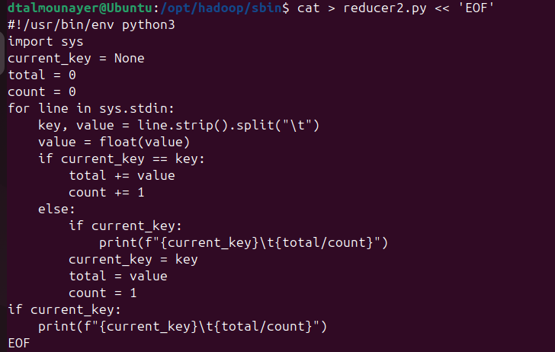
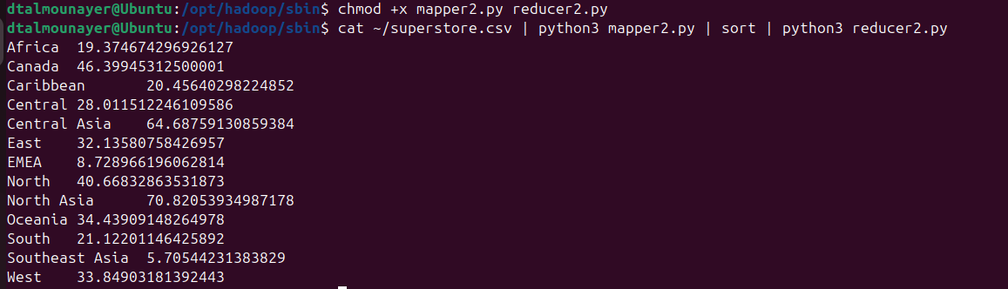
Interpretation: North Asia and Central Asia have the highest average profits, while Southeast Asia and EMEA are the lowest. This shows profitability varies significantly across regions, likely due to regional pricing or demand. Manual verification of two rows confirms results are correct.

Challenges & Lessons Learned
- Handling CSV with quoted fields and skipping headers required careful parsing.
- Hadoop streaming required files to be executable and proper path specification.
- Learned to test locally first before running on Hadoop.
- Next time, would validate CSV schema first to prevent index errors in mapper.

